The Project :

ABC Hotel Reservation System.

The Problem :

ABC Hotel is planning to automate its reservation system online. ABC Hotel has with AC and NON-AC rooms. In that, some are 2 bedrooms and some are 3 bedrooms. Hotel manager should have a facility to do the following in the application.

1. Add rooms which includes the availability (vacant or occupied) of each room
2. View all rooms in the hotel

While customer calls in to check the availability of a room, Hotel manager will get the requirements of customer in terms of 2 or 3 bedrooms, AC/NONAC and accordingly check whether the room is available.

If available, Hotel manager collects the customer name and address and allocate him a room number. Hotel manager should be able to view all occupied rooms with customer details.

Objectives :

The following are the objectives of the Hotel Reservation System are as follows :

- Customers can reserve rooms in the hotel online.
- Hotel manager can findout whether a room is available or not and convey this information to the customer.
- Hotel manager can quickly find out rooms acording to the needs of the customer.
- Hotel manager can record the details of the customer with a reservation in the hotel and view the same when needed.
- Hotel manager can add rooms to the inventory.

Scope :

Peliminary Ideas :

In Hotel Reservation system we have taken some assumptions which are as follows :
- The room numbers are allocated to the customers are in serial order, the customer cannot cannot choose his/her preferred room number.
- There is no provision for cancellation of reservation.
- There are a finite number of N rooms in the hotel, and out that N rooms N’ rooms are currently being used by customers, rest of the M = N – N’ rooms are not used. The hotel manager can add rooms for usage form M left over rooms when the currently used N rooms are all reserved.
- Hotel manager can view two lists, Firstly the list of all empty rooms, Secondly the list of occupied rooms.

The Feasibility Study
As the initial investigation is completed, it leads to a more detailed investigation
of the system. The conclusions of the initial study become the input for the
detailed study. We can also refer to the feasibility study as the detailed study or
detailed investigation. Feasibility study is called like because as in the first phase,
we just check briefly about the problems related to the old system, & the need of
the new system. So, in this phase, that initial survey is further expanded to a more
detailed feasibility study.

The tasks performed during this phase were as follows:

(a) The user.s demonstrable needs are fulfilled.
(b) The availability of resources was being checked.
(c) The estimation required for the resources were achieved.
(d) The impact of the system on the organization has been check by placing a model in it.

Requirement Analysis and Specification
Objective to Be Fulfilled:

(a) Development of software in the given time.
(b) To create an effective and efficient application.

User Requirements:

(a) The application should provide a user friendly environment.
(b) The application should be easily understandable and reliable.
(c) The application should fulfill all essential facilities.
(d) The software being built must provide platform independent application.

Requirement Determination Techniques & System Analysis Method:

(a) User communication
(b) Team discussion
(c) Analysis of existing system
(d) Study of old projects and records.

Design – High level and Low level

Data Structures :

Entity Relationship Diagram
Conceptual modeling is a very important part in designing a proper database application. Here the term database application refers to a software product that has a central database containing data and some associated programs that operate on the data in the database to give desired results of our queries. In the Hotel Reservation System problem we are representing conceptual model of the problem by the help of ER data modeling. An entity-relationship (ER) diagram is a specialized graphical representation that illustrates the interrelationships between entities in a database. ER diagrams often use symbols to represent three different types of information. Boxes are commonly used to represent entities. Diamonds are normally used to represent relationships and ovals are used to represent attributes.

For our database application consider a HOTEL RESERVATION database that keeps track of the rooms in the hotel taking care of the type of the room (ac/non-ac), number of beds in the room (i.e. 2 or 3 bedrooms), and most importantly this system keeps track which of these rooms are occupied by customers, or are yet not occupied but are reserved in advance by a customer, or it is available for booking. In addition to that our database also maintains the date when a customer checks in into the hotel and when he checks out of the hotel. Our HOTEL RESERVATION database also maintains the details of every customer that stays in the hotel, namely the customer’s Name and Address.

In our HOTEL RESERVATION system we have three entities: ROOMS, RESERVATION and CUSTOMER.

- ROOMS: This entity represents each and every room in the hotel. It keeps the specific details about each room in the hotel, such as the room number, whether it is ac or non-ac , how many beds does the room have and whether the room is already reserved. Thus the specific attributes of the ROOM entity are [ROOM_NO],[AC/NONAC],[NO_OF_BEDS],[STATUS].

- RESERVATION: For every room occupied by a customer , this entity contains one record. This entity keeps the date on which the room was occupied by the customer , the date on which the customer will leave the room or has left the room (which ever applies) , the corresponding room number and the reservation id. Thus this entity basically gives the snapshot of the hotel’s reservations. The specific attributes are [DT_OF_CHECKIN], [DT_OF_CHECKOUT],[RS_ID],[ROOM].

- CUSTOMER: This entity simply maintains the details about every customer in the hotel. It keeps the name, address and the room number where the customer will stay or has stayed in the past. The specific attributes are [CUST_ID],[NAME],[ADDRESS].

Now these three entities are related to each other by two relationships : TAKEN and MAKES,

- TAKEN: The entities ROOM and RESERVATION are related by the TAKEN relationship. We know that a customer reserves room in the hotel, so we say a room is temporarily taken by the customer. Thus the relationship taken between ROOM and RESERVATION is a 1:1 relationship, as there can only be 1 room in one reservation and no single room can have multiple reservations at the same time.

- MAKES: The entities CUSTOMER and RESERVATION are related by the MAKES relationship. In the HOTEL RESERVATION system if a customer wants to book a room, he/she has to reserve the room at advance, thus we say that the customer makes reservation at the hotel. Again a customer may want to reserve several rooms according to his needs, so in our HOTEL RESERVATION system we have also kept the provision for that facility. The relation MAKES is a 1:M relation between CUSTOMER and RESERVATION , as a single customer can make multiple reservations comprising of different rooms at different reservations but one reservation can never be made by multiple customers.

Entity Relationship Diagram

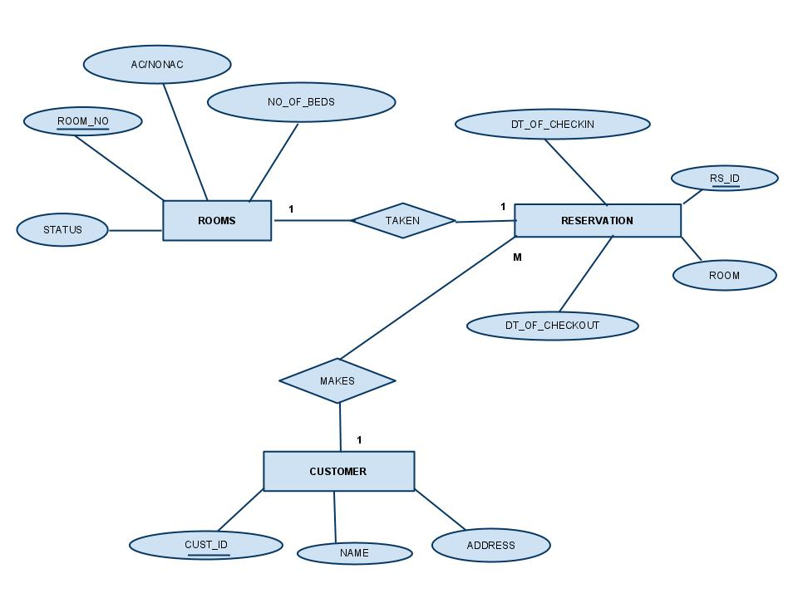

DATABASE DESIGN

Relational schamas and functional dependancies :
- RESERVATION(RS_ID , DT_OF_CHECKIN, DT_OF_CHECKOUT , ROOM_NO, CUST_ID)

This table consists of the reservation id [RS_ID] , date of checking-in [DT_OF_CHECKIN] , date of checking-out [DT_OF_CHECKOUT] and [CUST_ID]. This table maintains data of the reservations made by the customers made on daily basis. Here reservation id , [RS_ID] is the primary key.

This table has the functional dependancy :

- RS_ID → {DT_OF_CHECKIN,DT_OF_CHECKOUT,ROOM_NO}

In the above functional depandancy [DT_OF_CHECKIN] , [DT_OF_CHECKOUT] , [ROOM_NO] are dependant on the [RS_ID].

- RS_ID → { CUST_ID }

Customer id is dependant on the reservation id as a single customer can make a single reservation.

- CUSTOMER( CUST_ID , NAME , ADDRESS)

This table maintains the details about the customers of the hotel i.e. the customer id, name of the customer , address of the customer and reservation id . Reservation id is kept in this table so that we can find the reservation details about each customer by joining the CUSTOMER table and RESERVATION table. Here customer id ,[CUST_ID] is the primary key.

This table has two functional dependancies :

- CUST_ID → {NAME,ADDRESS}

Name and address of the customer depends on the customer id.

- ROOMS( ROOM_NO , AC/NONAC , NO_OF_BEDS , STATUS )

This table maintains the list of the rooms in the hotel along with the details of the rooms like 2 bedroom or 3 bedroom, AC or NON-AC and the room nunber. Here room number [ROOM_NO ] is the primary key. The status of the room depicts whether the room is reserved or is non-reserved.

This table has the following functional dependancy:
ROOM_NO → {AC/NONAC,NO_OF_BEDS}
All the attributes of ROOMS are dependant on the primary key.

CONTEXT DIAGRAM

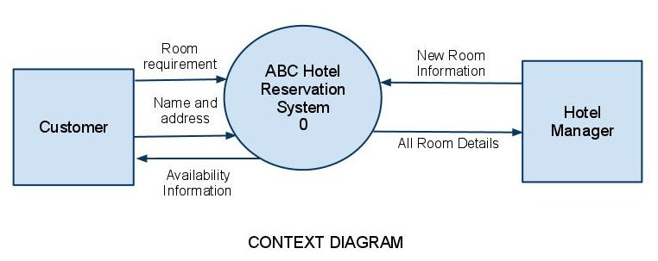

The Context diagram represents the entire system as a single module. The data values that are given to the system comprises of two types. First of all the new available rooms may be added to the system which the hotel manager does as and when the rooms are vacant. Secondly, a customer may call in to check availability of a room. The hotel manager then gets the room requirements from the customer and checks if such rooms are available. If the rooms are available then the customer’s name and address are taken and a room is allotted in his name. If rooms are not available the customer is informed of it. Apart from this the system also shows the details of all rooms present in the database.

DATA FLOW DIAGRAM

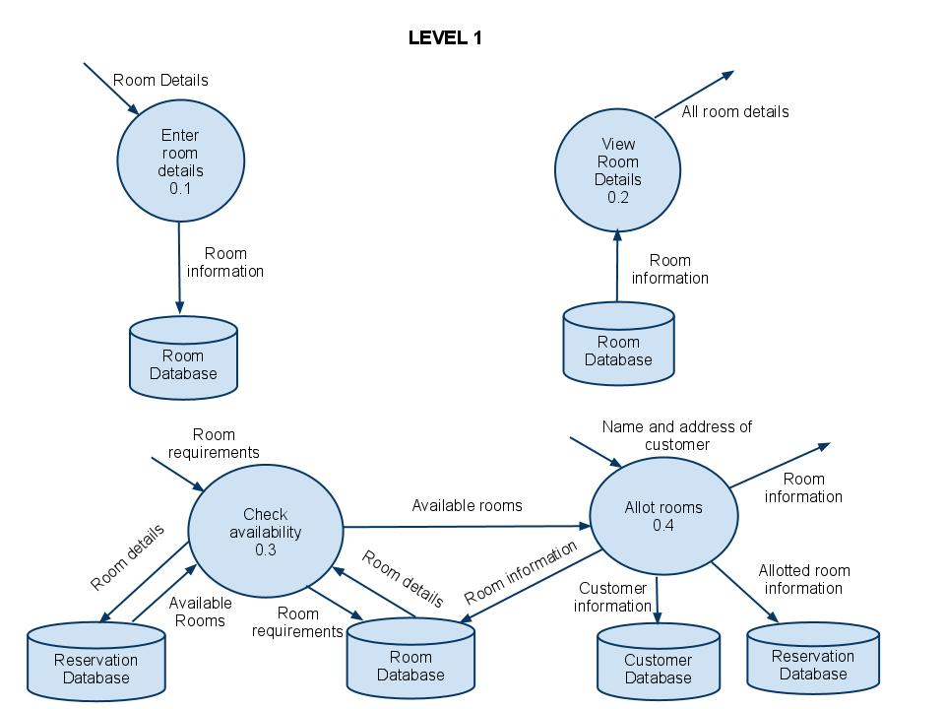

The Level 1 of the Data Flow Diagram shows Context diagram broken down into four modules. The Enter room details module takes the new rooms available and updates the Room database. When a customer checks out of the hotel the vacant room is again added to the room database. The View Room Details takes all the rooms present in the Room database and displays it for the hotel manager. The Check availability module takes the room requirements given by the customer and searches in the database whether such rooms are presents. If such rooms exist then it checks whether the rooms are available. If the rooms are available then it passes the room numbers to the Allot Rooms module which takes the name and address from the customer and stores it in the customer database and makes an entry in the reservation database. It also allots the room to the customer. If the rooms are not available the customer is informed of it.

